3GPP TSG RAN WG1 #125 R1- 2603869
Dalian, China, May. 18th ~ 22nd, 2026

Agenda Item: 10.8.3
Source: Apple
Title: On ISAC Waveforms and Frame Structure
Document for: Discussion

1 Introduction
From the RAN1#124b meeting, there are the following agreements related to sensing/ISAC waveforms and frame structure.

Agreement:
CP-OFDM waveform as defined for 6GR is the starting point for 6G ISAC waveform study.
Study on enhancements on CP-OFDM or other waveforms is not precluded.

Agreement:
6GR communication frame structure is the starting point for 6G ISAC frame structure study, in at least the following aspects.
- Frame/sub-frame/slot/symbol structure
- CP length
- SCS
Enhancements on frame structure/above aspects are not precluded.

Agreement:
Companies are encouraged to provide views on necessity/pros/cons/metrics of LLS and/or SLS and pros/cons/metrics of theoretical waveform characteristics analysis, for evaluation of ISAC waveform and/or integration with communication, to RAN1#125 meeting.

In this contribution we discuss 6GR ISAC waveforms,frame structure and evaluation methodology for waveform design to support 6GR sensing.

2 Waveforms

2.1 Background
Waveform design is a fundamental aspect of ISAC system design, as it directly impacts both sensing resolution, ambiguity characteristics, and detection performance, as well as communication throughput, and spectrum efficiency.

In the R20 5G-A ISAC study, gNB-based mono-static sensing (i.e., single TRP with co-located sensing transmitter and receiver) in a UMA-AV scenario for the UAV use case was analysed [3].. The existing DL NR waveform and DL NR reference signals were used for evaluations [1]. In 6GR, additional sensing modes, scenarios and targets are to be studied and the waveform to be used for sensing is a key study aspect.

For ISAC waveform, we can consider two categories of waveforms:
- Communications-centric waveforms such as OFDM/DFT-S-OFDM
- Sensing centric waveforms such as FMCW

2.2 Communication-centric Waveforms

It has been agreed from RAN1#124b that CP-OFDM is supported as 6G ISAC waveform.

One promising approach for OFDM-based sensing is to perform sensing operations in the frequency domain, where range and velocity estimation are carried out in the modulation-symbol domain. This decouples the sensing processing from the correlation properties of the baseband signal, offering greater flexibility in waveform design. In terms of signal composition, the sensing signal in an OFDM-based ISAC system can take various forms depending on the deployment scenario: it may consist solely of RS, applicable to both bi-static and mono-static configurations, or a combination of RS and data signals, which is particularly relevant in the mono-static case. Furthermore, the sensing signal may directly reuse existing communication signals, employ dedicated sensing-specific signals, adopt a hybrid approach combining both, or utilize specially designed dual-function signals that are jointly optimized for communication and sensing performance. A simplified and high-level diagram of frequency-domain OFDM sensing is given in Figure 1.

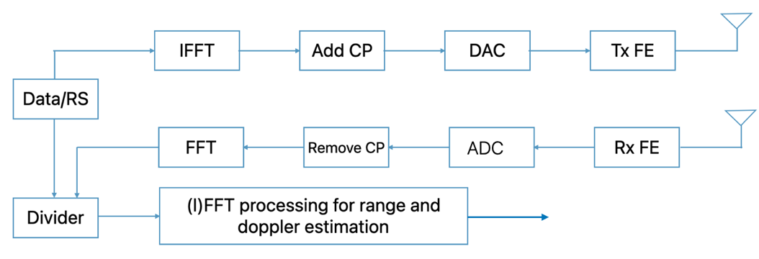
Figure 1. Frequency-domain OFDM sensing

It can be shown that with appropriate parameterization, OFDM can achieve the same/similar sensing performance as sensing-centric waveforms in terms of delay and doppler estimation.

Observation 1: OFDM-based Rx sensing processing may perform sensing operations in the frequency domain, where range and velocity estimation are carried out in the modulation-symbol domain

Observation 2: the OFDM sensing signal may consist solely of RS, applicable to both bi-static and mono-static configurations, or a combination of RS and data signals, relevant in the mono-static case.

Observation 3: the sensing signal may directly reuse existing communication signals, employ dedicated sensing-specific signals, adopt a hybrid approach combining both, or utilize specially designed dual-function signals that are jointly optimized for communication and sensing performance [5]

2.3 Sensing-centric Waveforms
Sensing-centric waveforms have been extensively studied in the radar community in the past several decades. Classical sensing waveforms are typically designed to carry no signalling information; instead, they are engineered to extract target-related parameters – such as range, velocity, and angle – from echoes reflected by objects of interest. Among the various radar waveform candidates, FMCW stands out as the most widely adopted and fundamental waveform.

An FMCW radar transmits a signal called a "chirp", which is a sinusoid whose frequency increases linearly with time. One FMCW pulse can be expressed as
(1)
where $f_{c}$ is the carrier frequency, $B$ is the bandwidth, $T$ is the pulse duration, $k$ is the frequency sweep slope and $k=B/T$. FMCW pulses are illustrated in Figure 2.
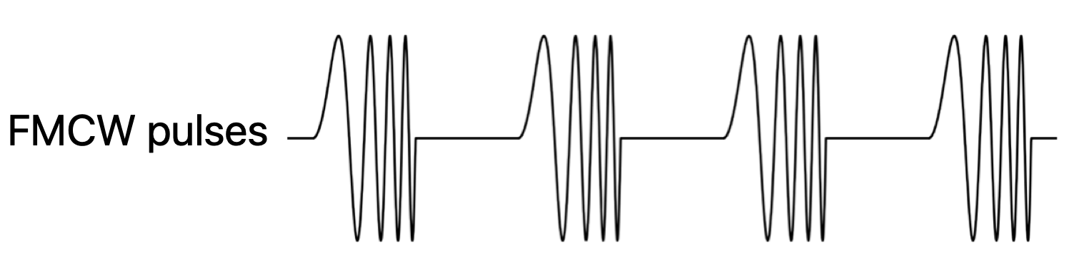
Figure 2. Illustration of FMCW pulses
In FMCW-based sensing, a series of FMCW chirps are fed to the Tx antenna and mixer at the receiver. After mixing the transmitted signals and the received signals reflected from the target, the beat signal is generated, which has a frequency proportional to the delay corresponding to the distance between the radar and the target. The beat signal is passed through a low pass filter and ADC for further signal processing implementation, e.g., target detection or sensing parameter estimation. The major attractive feature of FMCW is its simplified hardware components and low-cost receiver. This is thanks to the required low sampling-rate ADC, the cheap power amplifier, and the low PAPR of FMCW. Furthermore, for (UE) monostatic sensing, it is easier for FMCW to handle full-duplex self-interference at receiver side, due to the joint operations of dechirp and high-pass filter (HPF).

In the context of ISAC, when the design objective is to realize a joint communication and sensing waveform—whereby a single unified waveform simultaneously serves both communication and sensing functions—a central design aspect for FMCW-based approaches lies in how to embed information-bearing bits into the inherently data-agnostic FMCW waveform structure. One potential approach to carry information bits over FMCW is to modulate the chirp signal with a phase-coded sequence. However, the supportable communication data rate is low.
Observation 4: The major attractive features of FMCW for sensing are
- its simplified hardware components and low-cost receiver due to the required low sampling-rate ADC and the cheap power amplifier;
- easier handling of full-duplex self-interference at receiver side due to the joint operations of dechirp and HPF;
- low PAPR.
Observation 5: if needed for ISAC, the FMCW signal may be embedded with information-bearing bits

2.4 Waveform Comparison
Figure 3 illustrates the system parameters and Table 1 provides the qualitative comparison. As shown by Table 1, the performances are similar given the same system parameters. Note that the maximum unambiguous range of OFDM sensing also depends on the CP length. If the round-trip delay is longer than the CP length, there is ISI for sensing signals. Nevertheless, the ISI may not entirely prevent it from functioning.

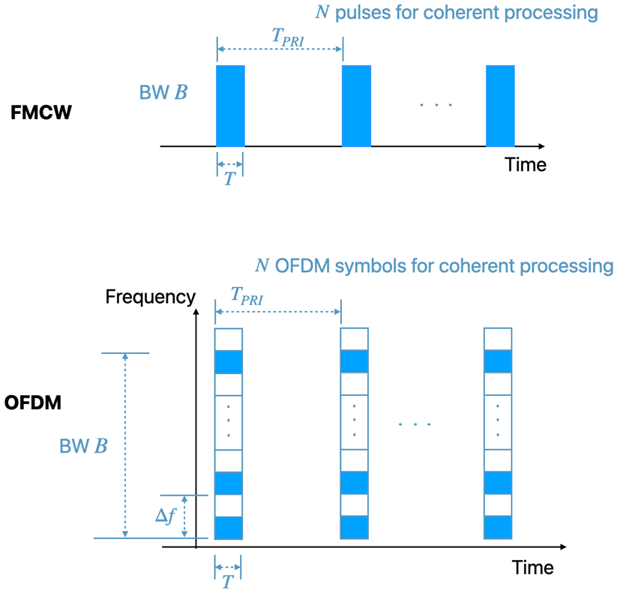
Figure 3: FMCW and OFDM sensing structure

Table 1. Qualitative comparison between FMCW and OFDM sensing performance
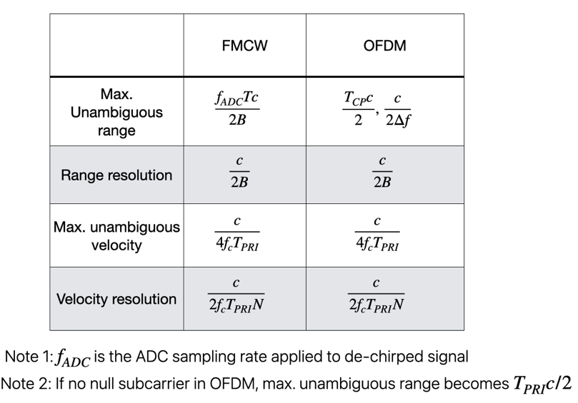
Moreover, the high-level quantitative performance comparison, in terms of sensing accuracy, communications data rate, PAPR and complexity (especially for a UE-monostatic sensing mode), is provided in Table 2.
Table 2. high-level quantitative comparison between FMCW and OFDM
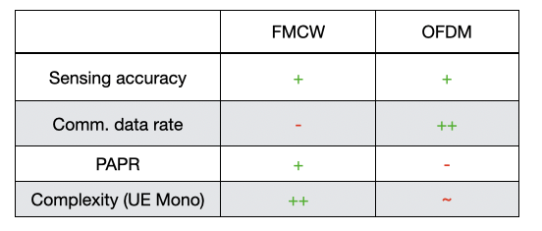

Observation 6: The limiting parameters for OFDM sensing are a function of the cyclic prefix length, the frequency spacing, the bandwidth, the pulse repetition interval and the coherent processing interval.
Observation 7: The limiting parameters for FMCW based sensing are a function of the bandwidth, the chirp time, the ADC sampling rate , the pulse repetition interval and the coherent processing interval.

2.5 6GR ISAC Waveform
CP-OFDM was agreed in RAN1#124b as the starting point of the 6G ISAC waveform study. However, as analyzed in Section 2.3, FMCW offer benefits from a sensing perspective, primarily on the receiver side, e.g., lower receiver complexity and easier handling of full-duplex self-interference.
In fact, there is an inherent equivalence between Zadoff-Chu (ZC) sequences and FMCW (or chirp) signals, which has been acknowledeged by multiple companies. Therefore, it should be possible to leverage the benefits of FMCW-style receiver processing even when the Tx waveform is OFDM-based ZC transmission.
In the following we will first show the equivalence between ZC and FMCW, and then describe the FMCW-style receiver processing when OFDM-based ZC is transmitted.
A baseband continuous time-domain FMCW/chirp signal is given by
$s\left(t\right)=e^{jπμt^{2}}$ with $t∈[0,T]$,
where $μ=B/T$ is the chirp rate/slope.
Then, a sampled discrete FMCW/chirp signal at $t=nT_{s}$ is given as
$s\left(n\right)=e^{jπμn^{2}T_{s}^{2}}=e^{jπαn^{2}}$,
where $α=BT/N^{2}$ , $T_{s}=T/N$, and $N$ the number of samples.
A ZC sequence defined in NR/LTE is
$x_{u}\left(n\right)=e^{jπun(n+1)/N_{ZC}}$,
where $u$ is the root of the ZC sequence. By comparing between ZC sequence $x_{u}\left(n\right)$ and the sampled FMCW signal $s\left(n\right)$, we see that by setting $α=-u/N_{ZC}$, the ZC sequence becomes the defined discrete chirp signal with an additional linear phase ramp.
If such ZC is transmitted with an OFDM architecture with certain sampling rate $f_{s,ZC}$, then the continuous time domain signal (with duration $T$) defined on the discrete time grid ${t=n/f}_{s,ZC}$ is given by
$x_{u}\left(t\right)=e^{-jπu(\frac{f_{s,ZC}}{T}t^{2}+\frac{1}{T}t)}=e^{jπ{(μ}^{'}t^{2}+f_{0}t)}$,
which is indeed a chirp signal with slope $μ^{'}=-uf_{s,ZC}/T$ and an additional phase ramp.
Observation 8: there is inherent equivalence between ZC sequences and FMCW/chirp signals.

After sending $x_{u}\left(t\right)$, the Rx signal (noise and doppler ignored for simplicity) is
$s_{Rx}\left(t\right)=x_{u}\left(t-τ\right)$.
Then, after dechirp by the local reference signal $s_{ref}\left(t\right)=e^{jπ{(μ}^{'}t^{2}+f_{0}t)}$, the beat signal becomes
$s_{b}\left(t\right)=s_{Rx}\left(t\right)×conj\left(s_{ref}\left(t\right)\right)=$ $e^{-j2πμ^{'}τt}×e^{jπ{(μ}^{'}τ^{2}-f_{0}τ)}=$ $e^{-j2πf_{b}t}×e^{jπ{(μ}^{'}τ^{2}-f_{0}τ)}$,
where the beat frequency is $f_{b}$=$μ^{'}τ$, which is exactly the same with classical FMCW dechrip outcome.
given the continuous time domain Tx chirp signal $x_{u}\left(t\right),$at receiver side it can be dechirped for sensing using an FMCW chirp $x_{ref}\left(t\right)$

Figure 4 presents a numerical evaluation of the range profile when a ZC sequence of length 839 and root index $u=4$ is transmitted using an OFDM architecture, with FMCW-style processing (as described above) applied at the receiver. As shown, the range profile exhibits a peak at the true target location.

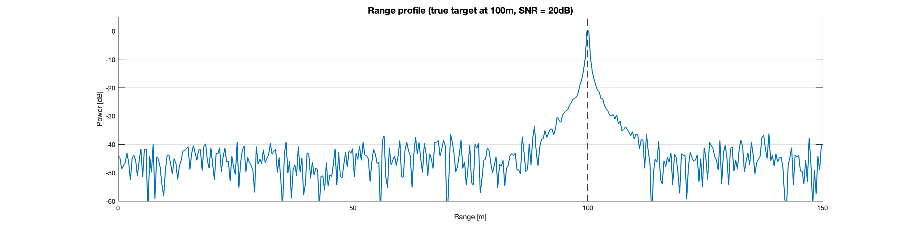
Figure 4. range profile of OFDM-based ZC transmission and FMCW-style Rx processing

Observation 9: FMCW-style Rx processing can be applied for sensing even when OFDM-based Zadoff-Chu sequence is transmitted.

Proposal 1: OFDM-based Zadoff-Chu sequence is transmitted as sensing signal to facilitate FMCW-style sensing receiver processing due to the attractive properties of FMCW (see observation 4 and [6] for details).

On the other hand, for sensing-only operations, especially with the UE as the sTX and/or sRX (UE monostatic, UE-TRP bistatic, TRP-UE bistatic and UE-UE bistatic), the sensing waveform can be TDMed with the communication system through the use of a dedicated transmission gap, as illustrated in Figure 5. In such cases, the sensing waveform may be explicitly specified in the standard to facilitate sharing of the sensing gap among multiple sTXs, or alternatively, its usage may be constrained based on transmission requirements defined in the specification.

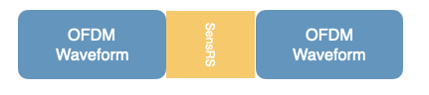
Figure 5. Transmission gap to facilitate sensing-only operations

Proposal 2: For sensing-only operation, especially with the UE as the sTX and/or sRX (UE monostatic, UE-TRP bistatic, TRP-UE bistatic and UE-UE bistatic), RAN1 should study TDM of a sensing waveform with communications using a dedicated transmission gap.

Proposal 3: RAN1 should study whether the sensing waveform and/or sensing transmission requirements within the transmission gap should be specified.

3 Frame Structure

Velocity/Doppler estimation in OFDM based sensing takes place over multiple symbols that may span multiple slots in a Coherent Processing Interval (CPI). For ideal sensing, power consistency and phase coherence and uniformity across the multiple sensing RS transmitted within the CPI is essential for some sensing modes e.g. bistatic sensing. This may impact the frame structure during dynamic TDD transmission. There may need to be coordination with communications resource configuration especially as the coherent processing interval may span multiple slots depending on the SCS. In addition, there may need to be a stable D/U pattern for that duration or a need to switch the dynamic TDD pattern to accommodate “opportunistic sensing” in response to a sensing trigger with a latency requirement. RAN1 should study the effect of the phase coherence requirement on the dynamic TDD frame structure. Note that in cases where Velocity/Doppler is not needed, e.g. in range estimation only, the requirements may be relaxed.

Secondly, in a scenario where there may be sensing requirements that determine the frame structure, the interacting between sensing and communications on the choice of TDD patterns may need to be studied.

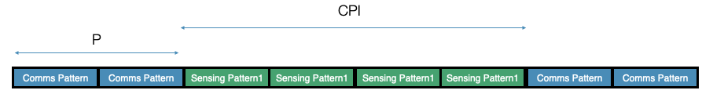

Proposal 4: RAN1 should study the effect of the phase coherence requirement on the dynamic TDD frame structure

4 Waveform and RS evaluation
In RAN1 #124, the following agreement was made to provide views on the need for theoretical waveform characterization and evaluations.

Theoretical waveform characteristics analysis: There is a need to identify and down-select appropriate theoretical metrics that correlate with a wide variety of sensing modes and requirements. Examples may include PAPR. Metrics like Auto/Cross correlation property are suitable for time domain receivers only and need to be discussed.
- Pro: Enables quick review of multiple waveform candidates
- Pro: Easily replicable among multiple companies
- Con: Metric may not translate to sensing performance
- Con: Metric may not map to sensing requirement, or sensing mode

Numerical Evaluation: There is a need to ensure that the waveforms selected based on the theoretical analysis improve sensing performance and requirements. As such numerical evaluation is necessary. A simplified numerical analysis may be needed with an LLS or simplified SLS used to establish the performance.
- Pro: Direct translation to sensing performance and requirements
- Con: Numerical evaluation may need LLS or SLS depending on sensing scenario/use case
- Con: Not generalizable

Proposal 5: RAN1 to use both Theoretical waveform characteristics analysis and Numerical Analysis for waveform study
- study and down-select theoretical waveform metrics AND use suitable numerical evaluation (LLS or simplified SLS) to evaluate waveform performance.

Conclusion
In this contribution, we provided our views on waveforms for 6GR ISAC with the following observations and proposals:

Observations:

Observation 1: OFDM-based Rx sensing processing may perform sensing operations in the frequency domain, where range and velocity estimation are carried out in the modulation-symbol domain

Observation 2: the OFDM sensing signal may consist solely of RS, applicable to both bi-static and mono-static configurations, or a combination of RS and data signals, relevant in the mono-static case.

Observation 3: the sensing signal may directly reuse existing communication signals, employ dedicated sensing-specific signals, adopt a hybrid approach combining both, or utilize specially designed dual-function signals that are jointly optimized for communication and sensing performance [6]

Observation 4: The major attractive feature of FMCW is its simplified hardware components and low-cost receiver due to the required low sampling-rate ADC, the cheap power amplifier, and the low PAPR of FMCW.
Observation 5: if needed for ISAC, the FMCW signal may be embedded with information-bearing bits
Observation 6: The limiting parameters for OFDM sensing are a function of the cyclic prefix length, the frequency spacing, the bandwidth, the pulse repetition interval and the coherent processing interval.
Observation 7: The limiting parameters for FMCW based sensing are a function of the bandwidth, the chirp time, the ADC sampling rate , the pulse repetition interval and the coherent processing interval.
Observation 8: there is inherent equivalence between ZC sequences and FMCW/chirp signals.
Observation 9: FMCW-style Rx processing can be applied for sensing even when OFDM-based Zadoff-Chu sequence is transmitted.

Proposals:
Proposal 1: OFDM-based Zadoff-Chu sequence is transmitted as sensing signal to facilitate FMCW-style sensing receiver processing due to the attractive properties of FMCW (see observation 4 and [5] for details).

Proposal 2: For sensing-only operation, especially with the UE as the sTX and/or sRX (UE monostatic, UE-TRP bistatic, TRP-UE bistatic and UE-UE bistatic), RAN1 should study TDM of a sensing waveform with communications using a dedicated transmission gap.

Proposal 3: RAN1 should study whether the sensing waveform and/or sensing transmission requirements within the transmission gap should be specified.

Proposal 4: RAN1 should study the effect of the phase coherence requirement on the dynamic TDD frame structure

Proposal 5: RAN1 to use both Theoretical waveform characteristics analysis and Numerical Analysis for waveform study
- study and down-select theoretical waveform metrics AND use suitable numerical evaluation (LLS or simplified SLS) to evaluate waveform performance.

References
- RP-253246, Revised SID: Study on Integrated Sensing And Communication (ISAC) for NR
- TR 38.914, Study on 6G Scenarios and Requirements (Release 20) .
- TR 38.765, Study on Integrated Sensing And Communication (ISAC) for NR (Release 20)
- TR 22.837, Study on Integrated Sensing and Communication
- R1-2602686 On Aspects of Integration of ISAC with Communications, Apple, May 2026
- R1-2603867 On Evaluations for 6G ISAC, Apple, May 2026

